Return on Investment Case Study:
North Star Educational Tools Electronic Performance Support System

Elizabeth A. Swenson
15809 Fescue Ct.
Apple Valley, MN 55124
Telephone: 218-330-2793
E-mail: Beth.Swenson@District196.org

Executive Summary
The Brainerd School District began implementation of the Literacy Collaborative Response to Intervention Model in 2003. In 2005 a needs assessment and gap analysis was conducted as a part of the annual yearend report. The needs assessment indicated classroom teachers were struggling to organize and utilize Observation Survey data to differentiate instruction. Teachers were also wasting valuable teaching time trying to copy and share data with Title I and special education teachers and assistants. Often the data wasn’t shared and intervention specialists were not aligning interventions to classrooms instruction.
To address these performance gaps, the North Star Educational Tools Electronic Performance Support System was created, allowing for real time sharing of data via a web based data graphing and warehousing system. The data was organized into graphs that identified students in need of intervention, as well as the specific areas of need. Both Specialists and classroom teachers used and updated data from the same graphs which aligned instruction and caused a significant shift in student achievement, including a significant drop in potential special education students.
In order to measure the impact of the intervention, the Phillips Return On Investment (ROI) methodology was applied. Five levels of objectives were written and an evaluation plan to measure reaction, learning, application, impact, and the Return on Investment(ROI) was designed, including a plan for how to collect and analyze all five levels of data. In addition, intangible benefits, barriers and enablers were identified. The Case Study and Forecast report also includes a communication plan to share the results, as well as an action plan for improvement of the Return On Investment (ROI) Process.
Table of Contents
Executive Summary ii
List of Tables vii
List of Figures ix
Introduction 1
Background Information 1
Target Organization 1
Background of the Performance Issue 1
Needs Assessment and Cause Analysis 2
Performance Intervention and Selection Process 3
Evaluation Objectives 3
Level 1 Objectives: Reaction and Planned Action 4
Level 2 Objectives: Learning and Confidence 4
Level 3 Objectives: Application and Implementation 5
Level 4 Objectives: Business Impact 6
Level 5 Objectives: Return on Investment 7
Data Collection Plan 8
Isolation Methods 9
Trend Line Analysis 10
Benefits and Cost Calculation 11
Intangible Benefits 11
Intervention Costs 13
Results Communication Plan 16
Full Results of the Return on Investment Study 20
Level I – Reaction and Planned Action 20
Level 2 – Learning Results 21
Level 3: Application Data 21
Level 4: Impact Data 22
Level 4: Shifts in Trend Lines after Implementation 23
Methods for Converting Data to Money 25
Total Program Costs 26
Total Impact of the Intervention 26
Level 5: Return on Investment of Implementation 27
ROI Business Impact Forecast for 2010-2011 School Year 27
Action Plan for Improvement 28
Conclusions 38
Recommendations 38
References 39
Appendix A: Baseline Data 41
Appendix B: Gap Analysis 42
Appendix C: Stakeholders 43
Appendix D: Objectives and Data Collection Plan 44
Appendix E: Trend Lines for End of the Year Benchmark Assessment Performance Level: Does Not Meet Expectations 46
Appendix F: Standardized Cost of Educating a Special Education Versus General Education Student in 2000 47
Appendix G: Trend Lines for End of the Year Benchmark Assessment Performance Level: Partially Meets Expectations 48
Appendix H: Standardized Cost for Educating a Title I student in Brainerd, MN in 2002 49
Appendix I: Trend Lines for End of the Year Benchmark Assessment Performance Level: Meets and Exceeds Expectations 50
Appendix J: Job Aid: Steps to Determine the Most Feasible Method(s) of Isolation 51
Appendix K: Isolation Selection Tool 52
Appendix L: Cost Estimating Worksheet 53
Appendix M: Converting Trend Line Data to Monetary Values 57
Appendix N: Results Communication Plan 62
Appendix O: Action Plan for Improvement 63
Appendix P: End of Program Calculated Amounts 64
Appendix Q: Forecasted Student Cost Per Targeted Assistance Zone 66

List of Tables
Table 1: Measuring Intangibles 12
Table 2: Average Per Pupil Cost per Target Zone 15
Table 3: Formula to Calculate Amount of Financial Return Needed to Make 25% ROI Goal. 16
Table 4: Stakeholders Communication Needs 17
Table 5: Results of Performance Check List 21
Table 6: Shifts in Students’ Targeted Assistance Zones After Implementation 22
Table 7: Converting Data into Monetary Values 25
Table 8: Total Program Costs 26
Table 9: Total Impact of Intervention 26
Table 10: Converting Business Forecast Data into Money 28
Table 11: NWEA Testing Data Over Time Study 33
Table 122: Interim Barriers that Were Solved During Implementation 35
Table 133: Barriers and Enablers 36
Table 14: Gap Analysis results from data compiled from data brought to the focus session. 42
Table 15: Objectives and Data Collection Plan 44
Table 16: Standardized Cost for Educating a Title I student 49
Table 17: Isolation Selection Tool 52
Table 18: Cost Estimating Worksheet 53
Table 19: 2004-2005 Actual Student Cost Per Targeted Assistance Zone 57
Table 20: 2005-2006 Student Cost Per Targeted Assistance Zone 58
Table 21: 2006-2007 Student Cost Per Targeted Assistance Zone 58
Table 22: Calculating average number of students per year to use for projections 59
Table 23: 2007-2008 Projected Student Cost Per Targeted Assistance Zone 59
Table 24: 2008-2009 Projected Student Cost Per Targeted Assistance Zone 59
Table 25: 2009-2010 Projected Student Cost Per Targeted Assistance Zone 60
Table 26: Pre Intervention Average Cost Per Child 60
Table 27: Projected 3 Year Average Per Child 61
Table 28: Results Communication Plan 62
Table 29: Action Plan for Improvement 63
Table 30: 2007-2008 Student Cost Per Targeted Assistance Zone 64
Table 31: 2008-2009 Student Cost Per Targeted Assistance Zone 65
Table 32: 2009-2010 Student Cost Per Targeted Assistance Zone 65
Table 333: 2007-2008 Forecasted Student Cost Per Targeted Assistance Zone 66

List of Figures
Figure 1: Bar Graph of Level I Survey Results After Training 20
Figure 2: Trend Lines for End of the Year Benchmark: Does Not Meet Expectations 23
Figure 3: Trend Lines for End of the Year Benchmark: Partially Meets Expectations 24
Figure 4: Trend Lines for End of the Year Benchmark: Meets and Exceeds Expectations 24
Figure 5: Return on Investment 27
Figure 6: ROI Business Impact Forecast for 2011 28
Figure 7: Lack of correlation between AIMS Web Scores and state test. 31
Figure 8: Baseline data 41
Figure 9: Projected Trend Lines for Does Not Meet Expectations 46
Figure 10: Standardized Values for Cost of Educating Special Education Student and General Education Student 47
Figure 11: Projected Trend Lines for Partially Meet Expectations 48
Figure 12: Projected Trend Lines for Meets and Exceeds Expectations 50

Introduction
The Brainerd School district commissioned the development and the implementation of the North Star Educational Tools Electronic Performance Support System that would organize assessment data into graphs that pin pointed instructional focuses that allowed teachers and specialists to align instruction and close student achievement gaps. The Return on Investment(ROI) Study measures the results of implementing the North Star Educational Tool Electronic Performance Support System and its impact on teacher performance and student achievement.

Background Information

Target Organization
The Brainerd School District has been involved in a comprehensive school reform effort for ten years. The rural school district, established in 1871 in Brainerd, Minnesota has 15 schools, 27 administrators, 399 teachers, and 7,142 students, and a graduation rate of 95%. The targeted K-2 population has an average class size of 29 students, an average poverty rating of 49.6%, and six of the eight elementary schools receive federal funding for Title I. The adopted Literacy Collaborative research based coaching and staff development model created a paradigm shift from the traditional teach-test model, to a less familiar assess and progress model (Forbes, Swenson, & Person, 2008). The district implemented the response to intervention model in order to increase student achievement, as well as reduce duplicated services and expenditures associated with increased special education numbers. The bottom line for the district is to achieve the district mission: We are committed to quality schools where all students learn well.

Background of the Performance Issue
The Literacy Collaborative requires research partner schools to differentiate instruction based on quarterly benchmark data from The Observation Survey of Early Literacy Learning Assessment (Clay, 2002). The assessment has six subtests of data, resulting in a report of 8-12 pages, containing hundreds of bits of raw data for each student, by the end of a testing period. As a result, learning to organize and utilize the data to inform instruction is difficult for teachers.

Needs Assessment and Cause Analysis
Two years into the school reform effort, district Literacy Coordinators participated in a focus group to assess progress in the model. Coaching rubrics indicated teachers had increased ability to teach the structure of the balanced literacy framework: guided reading, shared reading, read alouds, and writer’s workshop, but the lessons were still targeting the average student, so student achievement data was not improving at the desired rate and special education learning disability numbers were not dropping significantly as expected (see Appendix A for baseline data).
Literacy Coordinators conducted interviews with teachers from each grade level in assigned buildings. Teachers indicated difficulty with organizing hundreds of bits of data per child. Differentiating instruction was difficult without a convenient way to access the data. Teachers also indicated that without access to the data, Title I and special education teachers and education assistants were conducting random acts of intervention. Teachers and assistants were teaching in silos, unaware of the focus of each other’s efforts, often duplicating, or undoing each other’s teaching. Scarce intervention resources were being wasted by assigning assistants and specialists to classrooms by equal numbers of minutes, instead of student need. In some rooms adults stood around watching, while in others large clusters of kids with differing needs were grouped together to try to meet all needs with less support (see Appendix B for gap analysis).

Performance Intervention and Selection Process
Teachers indicated a need for a system to organize and share data expeditiously, without having to spend precious teaching time making copies. The stakeholders group of school board, superintendent, principals, teachers, Title I, special education, teaching assistants and parents met to brainstorm possibilities (see Appendix C for list of stakeholders). The group eventually voted to create an electronic performance support system that would automatically graph data in a paperless web based data warehouse. With security logins, the data was available on any computer at any time. Every person that worked with a child could update the same data graph, allowing constant communication without cumbersome meetings or expensive photocopying. The tool then could be marketed to other sites to help pay for upgrades. (www.northstaret.com, 2007).

Evaluation Objectives
Clear objectives let everyone involved know what must be done to achieve success and what the consequences of that success were. Actions (applications) and consequences (impact) represent the important outcomes from almost every program. When these objectives are clearly stated, stakeholders can define the actions they need to take to succeed in program implementation. (Phillips & Phillips, 2008, p.6)
The following objectives, written at all five levels of the Return on Investment(ROI) Process Model, served as a guide to ensure all stakeholders understood what needed to be done to achieve success with the North Star Educational Tools Electronic Performance Support System intervention. The objectives were written with evaluation in mind to record the impact on the district needs (Phillips & Phillips, 2007), to reduce special education numbers, and show increased student achievement to meet Adequate Yearly Progress (AYP) and maintain funding. Reducing the number of special education and Title I students would reduce the overall federal, state and local cost of education.

Level 1 Objectives: Reaction and Planned Action
Level 1 objectives were written to ensure that energy was spent focusing on ways to secure the support, satisfaction, and the usage of the intervention. To create buy-in and penchant for the North Star Electronic Performance Support System, training was designed to orient participants to the tool. In order to measure the satisfaction of the participants, a questionnaire was created using a five point Likert scale. The questionnaire contained eight formal measurable questions as well as two informal open ended questions, used to collect data from the participants at the close of the training session. By the end of the training, stakeholders anticipated an average rating of four out of five on the questionnaire, indicating a strong intent to use the system, as North Star was important and relative to participants’ success of differentiated instruction, (see Appendix D for objectives). Data from the questionnaire was used to measure satisfaction as well as improve the training for future cohorts of learners.

Level 2 Objectives: Learning and Confidence
Level 2 learning objectives were written to clearly communicate learning expectations and describe competent performance, condition, and criterion that calculate the outcomes of training (Phillips & Phillips, 2008). The learning objectives were posted at the beginning of the North Star Electronic Performance Support System orientation training, and the facilitator explained that participants would complete a simulation exercise at the end of training, to demonstrate participants’ learning. Participants were given a copy of the performance checklist, used to score learners during the simulation exercise, as a note taking reference tool during the training. Each item on the performance checklist was explained, demonstrated, and then completed again with learners following along and applying the learning as the training unfolded. Training Facilitators differentiated instruction to ensure participants could confidently perform all actions indicated on the checklists. Participants were allowed time to practice the new learning.
During the training, facilitators formally observed participants entering, printing, and selecting interventions and checked off competencies using an electronic performance checklist. Learners were required to correctly demonstrate all 26 measures on the performance check list to pass the course in a training simulation exercise (see Appendix D for objectives). If learners were unable to score 26/26 on the performance checklist, immediate remedial training occurred and a second neutral facilitator observed the simulated exercise and scored it with a performance checklist. If learners could not pass on the second testing, follow up sessions were scheduled until participant’s could successfully score 26/26 on the performance checklist, guaranteeing participants’ success with learning objectives before applying them on the job.

Level 3 Objectives: Application and Implementation
Application and implementation objectives clearly identified specific behaviors, tasks, and actions that were observable, measureable, and were a result of the North Star intervention (Phillips & Phillips, 2008). Participants applied the learning from the training by correctly entering and utilizing quarterly benchmark data for instruction. Participants used a self assessment performance checklist as a tool to measure application performance as the data was entered. The checklist was sent to the district trainer, indicating data entry was finished. The district trainer reviewed the data entry using an identical performance checklist. Discrepancies between the coach and participant were used for re-teaching during coaching to ensure a score of at least nine out of ten by every participant using the checklist (see Appendix D for objectives).
Participants completed the right side of an action plan before each coaching session, indicating an appropriate balanced literacy tool to teach for a shift in student reading and writing. The coach measured the teachers’ application of the data in teaching with a minimum score of seven out of ten on the data analysis and application coaching rubrics (Fountas & Pinnell, 2005).

Level 4 Objectives: Business Impact
According to Phillips & Phillips (2008), “Impact Objectives must contain measures linked to the skills and knowledge gained as a result of the program.” (p.100). Impact measures must be specific, results based, easily collected, and should indicate what participants have accomplished as an outcome of the intervention (Phillips & Phillips, 2007; Phillips & Phillips, 2008; Phillips & Phillips, 2010).
The North Star Educational Tools Targeted Assistance Zone Report with trend lines measured changes in student achievement by recording shifts in all targeted assistance zones. The red zone (students below 20th percentile) were projected to reduce by 20% as measured by the classroom targeted assistance reports using the North Star Educational Tools Targeted Assistance Zone Report trend line (see Appendix E for does not meet expectation trend lines). Students in the red zone who were not already identified as special education were referred to child study if documented in the red zone for three consecutive testing periods. Increasing a teacher’s ability to differentiate instruction using data from the North Star System was projected to decrease the number of students in the red zone by 20% at the end of the 2009-2010 school year. The impact of the reduction was calculated using the cost of educating a special education student versus the cost of educating a general education student using standardized costs (see Appendix F for standardized values). The difference between actual and projected numbers of students in the red zone was calculated as cost savings.
Students in the yellow zone (students below 50th percentile) were projected to reduce by 20%, as measured by the Targeted Assistance Trend Line Report (see Appendix G for partially meets expectation trend lines). Increasing a teacher’s ability to differentiate instruction using data from the North Star System was projected to decrease the number of students in the yellow zone by 20% at the end of the 2009-2010 school year. The impact of the reduction was calculated using the cost of educating a Title I student versus the cost of educating a general education student using standardized costs (see Appendix H for standardized values). The difference between actual number of students and projected numbers of students in the yellow zone were calculated as cost savings.
Students in the green (students at the mean) and blue (students above high benchmark) zones were projected to increase by 40%, as measured by the Targeted Assistance Trend Line Report (see Appendix I for meets and exceeds expectations trend lines). These students require only the base general education expenditures to educate. Kindergarten through second grade special education numbers were projected to decrease by 20% by the end of the instructional year, as a result of the North Star Electronic Performance Support System intervention.

Level 5 Objectives: Return on Investment
The final objective is the Return on Investment (ROI) objective. A positive Return on Investment (ROI) was needed to show that the cost of the North Star Electronic Performance Support System was a positive investment, rather than an expense. A conservative Return on Investment(ROI) value lead to greater credibility than forecasting high and falling short (Phillips & Phillips, 2008a). The stakeholders projected the North Star intervention will attain a benefit-cost ratio of 1.25:1 and represent a Return on Investment (ROI) value of 25%, using the first five years of benefits (see Appendix D for objectives).

Data Collection Plan
An organization should have a data collection and storage plan in place before the data is collected. The plan helps to ensure fidelity in usage of the data collection tools, timeliness of data collection, and assignment and training of data collectors. Having the data plan in place before implementation allows time for feedback and buy-in from stakeholders, which ultimately leads to greater accountability and follow through (Phillips & Phillips, 2008). The North Star Data Collection Plan (see Appendix E for the plan) contains the program objectives and forecasted measures of those objectives from each level.
Level 1 data were collected using a questionnaire to measure the reaction and planned action as a result of the training. The questionnaire contained eight questions measured using a five point Likert scale. The questionnaire also contains two informal open ended questions for indicators of barriers, enablers, and intangibles.
Level 2 data measured if the participants learned how to use the North Star Electronic Performance Support System correctly in the training. Formal observation of the actions learned occurred in a simulation at the end of training and a performance checklist was used to measure all twenty-six items learned in the training.
Level 3 data measured if the participants could apply the information learned in the training on the job. Regular coaching rubrics were used to record the application of the new data tools on the job. A score of seven out of ten on the data analysis and application coaching rubric was the minimum pass rate to show successful implementation.
Level 4 benchmark assessment data was collected every quarter for three years, and entered into North Star Assessment Tools (Swenson, 2007). Trend lines were projected from the historical data collected three years prior to implementation of the North Star Electronic Performance Support System (see Appendix A for baseline data ). The trend line was completed with yearend data from the three years following initial implementation. The savings in cost to educate the cohort of children was calculated every year, using standard costs (see Appendices F and H for standardized values). A large cost benefit was achieved by moving students out of special education and Title I at a greater rate than the projected trend line. The goal was to reduce special education rates by 20% by the end of Kindergarten – second grade. The goal was to drop the Title I rates 20%, and increase the meets and exceeds candidates by 20% as measured by the Targeted Assistance Report (see Appendix D for data goals).
Level 5 ROI data was calculated by converting the level four data to dollars saved. The project goal was to have a benefit-cost ratio of 1.25:1, and an ROI value of 25% using the first year benefits.
Care was taken to ensure that the data collection tools matched the level and type of data, the sources for that data, the timing for data collection, and the person or team responsible for collecting the data. The Literacy Collaborative District Trainer monitored the data collection plan and provided monthly update emails with progress reports to all stakeholders.

Isolation Methods
The only way to show the specific business impact that an intervention has on performance improvement is through isolation. Many factors may contribute to the improvement seen in the data so it is important to isolate the effects of an intervention. The first step in isolation is selecting the appropriate technique early in the process as a part of the evaluation plan. Early planning will ensure choosing the most rigorous technique appropriate, keeping in mind cost and time as well as effectiveness of isolation (Phillips & Aaron, 2008).
Using the Steps to Determine the Most Feasible Method(s) of Isolation tool (see Appendix J for tool), it was determined that trend line data would highlight the effects of the North Star Educational Tools Electronic Performance Support System on the growth of students. The most accurate method of isolation is control groups. Although data was available for matched pairs with control groups, isolation selection (see Appendix K for isolation tool), determined control groups to be unworkable because the district has the goal of getting all schools to use North Star data during the study period. In education it is unethical to have schools commit to several years of not using a tool (control group) that could help teachers close student achievement gaps.
Trend line analysis of performance data is the second most accurate way to isolate the effects of interventions. Since multiple years of historical student performance data was already available in trend line reports through North Star, and there are no other influencing factors, trend lines were the most economical isolation method available. The trend line isolation method was applied and none of the other influencing factors arose during the study.

Trend Line Analysis
Heinemann Benchmark Assessment System Data is collected four times per year for every school in the district. Since historical data was available, only the yearend benchmark data was used to show shifts in teaching. Pre-intervention historical data was collected and trend lines drawn for: does not meet expectations (see Appendix E for does not meet trend lines), partially meets expectations (see Appendix G for partially meets trend lines), and meets and exceeds expectations (see Appendix I for meets and exceeds trend lines). These benchmarks represent the levels of interventions a child needs to close achievement gaps. Students in the does not meet category require a triple dose of instruction to close gaps, children in the partially meet require a double dose of instruction to close achievement gaps, and children in the meet and exceed categories require only the regular classroom core instruction to reach high benchmark by the end of the year. Trend Lines were drawn illustrating the historical growth rate in all four benchmark areas. Trend lines were projected based on average student growth through three additional years. The pre-intervention average was calculated, as well as the projected post intervention average based on the trend line (see Appendices E, G, and I: Trend Lines).
Ruling out other internal and external factors that could influence the measure during the established time frame is critical to trend line analysis. The trend line isolation method (see Appendix J for isolation job aide), was used to identify other factors that could have possibly influenced growth over time in performance data. It was determined that the only new intervention added in the summer of 2007 was the North Star Educational Tools Electronic Performance Support System. The other identified factors were monitored over time but none of the factors occurred during the study.

Benefits and Cost Calculation

Intangible Benefits
The trend line isolation graphs illustrate that the Brainerd School District was making gains in student achievement using the Literacy Collaborative Comprehensive Reform Model. The model included coaching, staff development, and standardized data from Clay’s (2008) Observation Survey driving instruction. The gains were significant, but came at the cost of decreased job satisfaction, decreased efficacy, increased job stress, increased amount of time trying to share the hand graphed data across the silos of special education, Title I, general education, administration, and paraprofessionals. The needs assessment highlighted the need for the tool and indicated that it would turn around these negative aspects of school reforms into positive ones.
Intangibles are important to record and measure if possible, as intangibles help to market a company to future employees and to secure funding for a project or intervention. Intangibles are just as important to identify as tangibles in a Return on Investment (ROI) project, the only difference according to guiding principle number eleven, is that intangibles are measures that cannot be easily converted into monetary values with credibility, or with a minimum of resources, according to ROI Guiding Principle Number Eleven (Phillips& Phillips, 2007b).
The intangibles for the North Star Educational Tools Electronic Performance Support System include, but are not limited to, the intangibles identified in Table 1.
Table 1: Measuring Intangibles
Intangible | Measurement Strategy
Reduced Job Stress | Documented in open ended questions on surveys
Increased Teacher Efficacy | Documented in open ended questions on surveys
Increased Coach Efficacy | Documented in open ended questions on surveys
Increased Coaching cycles which allow a coach to get in earlier on the change curve to reduce the impact of change. | Measured on coaching notes and reflection by coaches
Increase Job Satisfaction | Measured on an electronic survey using a Likert scale to collect before and after data
Increased involvement of principals with monitoring data | Documented with log-in history on North Star
Decrease in departmental silos, increase of interdepartmental sharing of data and teaching. | Documented in open ended questions on surveys
Other intangibles were collected from participants. | Documented in open ended questions on surveys

Intervention Costs
In order to determine the value of an intervention, it is important to include all costs, both direct and indirect. All costs must be fully loaded and conservative, to develop credibility of the calculations. Costs must represent all four stages of an intervention, analysis, design & development, implementation, and evaluation stages (Phillips & Burkett, 2008).
The analysis stage included the needs assessment survey and analysis, as well as a study of existing data collection options. Costs were calculated for the outside source who conducted the online survey and created a data summary. Costs were also calculated for the stakeholders team meetings in which various solutions were presented and discussed. The final decision was to invest in an electronic performance support system that could be marketed to cover the costs of development and usage.
The design and development stage included contracting with an outside developer to use the tools the district trainer had developed to code them into the online tool. Although the basic design was in place before the idea to develop the product, as well as the time being donated, the cost of development was still included to make sure the estimate was conservative, and fully included all costs, even if donated. Using the most conservative alternative is important to the credibility of the project (Phillips & Phillips, 2007a). Additional costs were included such as marketing, brochures, and website design, in attempt to make the tool marketable, so the district could recover some of the cost of development and implementation.
The implementation phase involved training and use of the tool. Again the cost of hiring a trainer was figured in to ensure conservative estimates, even though the trainer had donated time. Time was calculated to include two hours of training for every employee on proper use of the tool. The evaluation phase involved another survey, as well as analyzing the intervention data at all four phases of implementation. Costs were calculated for every phase using the Cost Estimating Worksheet (see Appendix L for program costs).
Converting Data into Monetary Values
The over arching goal of the North Star Educational Tools Electronic Performance Support System intervention is to increase student achievement, by helping teachers to organize data in a meaningful way to better inform teaching. At the same time, the data needed to be accessible to coaches, intervention specialists, and a team of support people who surround the classroom teachers in order to raise student achievement to cut down the time spent graphing data by hand and trying to meet with specialists and education assistants to share the data.
North Star student achievement is easily translated into monetary values, using standardized values for per pupil education costs. To be very conservative, the per-pupil cost for educating a special education student was calculated by consistently using the 2000 National Standard Value (Chambers, Parrish, & Harr (2002). According to Special Education Expenditure Project Director, Center for Special Education Finance Director, and Report Production Team Leader respectively, the average cost of educating a special education child in 2000 was $12, 474. The same report states that the cost of educating a general education student that same year was $6,556. It costs nearly twice as much to educate a special education student as it does a general education student (see Appendix for standardized value).
Figures for Title I per pupil costs are only archived back to 2002, so for the purpose of the study the per pupil cost of Title I will add the 2002 Title allocation per student to the 2000 general education allocation. Although these are not consistent, both values are several years before the study and are conservative figures. The average per pupil cost of educating a Title I student was calculated on a per district formula. According to the US Department of Education (2002), the average cost of educating a Title I student in Brainerd MN is $1,111, in addition to the typical general education per pupil amount (see Appendix H for standardized value). The average total per pupil cost of a Title I student was conservatively calculated combining the Title I per pupil additional amount and the general education amount to reach a total of $7667 per pupil unit.
Table 2: Average Per Pupil Cost per Target Zone
Average Yearly Per Pupil Cost of Educating a Child
DNM | Does Not Meet Expectations | Special Education | $12,474
Partially | Partially Meets Expectations | Title I | $7667
Meets | Meets and Exceeds Expectations | General Education | $6556
Exceeds | Meets and Exceeds Expectations | General Education | $6556

The baseline data and projected trend lines were converted to show an example of calculating monetary value with data. The number of students per targeted assistance zone was multiplied by the cost per zone. The total cost of educating the children in the current zones was calculated and divided by the total number of children, to account for changes in numbers of students each year. The increases or decreases in the overall average per pupil cost will show an increase or decrease cost to educate the child. The average number of students per school year was calculated and multiplied by the average per pupil cost to figure out an average gain or loss in total spending. Teachers use the data more efficiently and effectively to close achievement gaps and shift kids out of the more expensive zones, and into zones that require less costly supplemental help (see tables 19-27 in Appendix M for detailed calculations).
The average cost for educating children for the three years before the intervention was $8217 (rounded). The average cost per child was multiplied times the average number of kids educated the total pre-intervention average is $13,147,068 (see Table 26 in Appendix M for detailed calculations). The total for three year average would be $39,441,204.
The average cost projected out with trend lines for educating children for three additional years would be $8,074 (rounded). Multiplied times the average number of students educated, the total projected three year average is $12,918,213 (see Table 27 in Appendix M detailed calculations). The total projected with trend lines for three years would be $38,754,639. The difference between the first three years and the projected second three years is: $39,441,204 - $38,754,639= $686,565 in continued savings if there was no intervention implemented. The goal for the Return on Investment (ROI) after the intervention is 25%. To make the 25% (Return on Investment) ROI goal, an additional $285,676 must be saved on top of the projected $686,565 amount. That is an average impact of $95,225 per year. An Algebraic formula was used to decipher the amount needed in addition to trend line projections to make the 25% Return on Investment (see Table 3 for formula),
Table 3: Formula to Calculate Amount of Financial Return Needed to Make 25% ROI Goal.
In order to get the return, the savings after the intervention must be: $686,565 = X + intervention costs ($329,470) times 125%.
$686,565 = X + 329,470 times 125%
$357,095= 1.25X
X = $285,676

Results Communication Plan
Each group of stakeholders in the Brainerd School District has different communication needs that differ in frequency, type, media, and detail of communication needed. It is important that results are communicated in a timely manner.
Table 4: Stakeholders Communication Needs
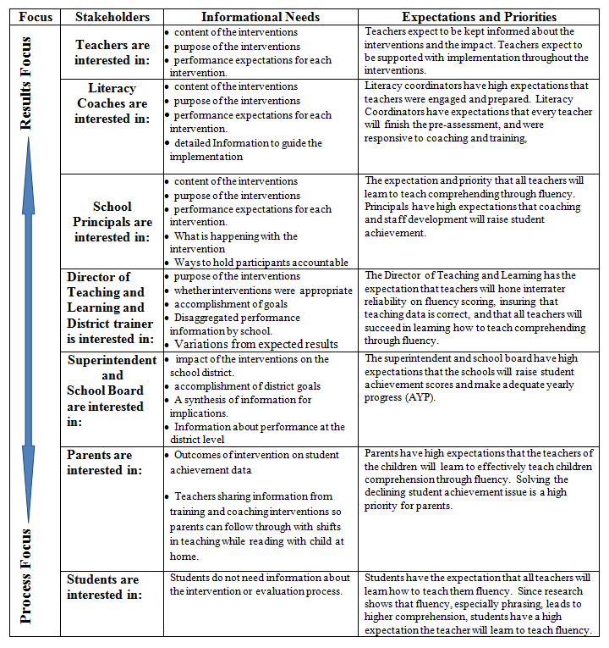
The high level administration was very involved in the early stages of the intervention. The superintendent met with the district trainer on July 7, 2007 to draft a proposal for the Return on Investment (ROI) project using the needs assessment and gap analysis data. It is important for teachers, coaches, principals, and upper administration to be a part of the planning process through the needs assessment and follow up with face-to-face meeting to ensure ownership. The intervention selection was grounded in data gleaned from the Needs Assessment and Gap Analysis (see Appendix B for Gap Analysis). During the meeting a timeline and list of resources were generated and communication needs for stakeholders were discussed. The communication strategy was considered paramount as it would shape the teachers and coaches’ opinion of the program team. (see Appendix N for the communication plan).
The District Trainer polished the proposal and presented it at the July 14, 2007 school board meeting for approval. The board unanimously approved the project and allocated the funding and resources needed to complete the project. On July 28, 2007 the superintendent and district trainer met with the team of principals to explain the project, and the administrative leadership role of helping create teacher buy-in for the project. The principals introduced the project to the teachers between July 28th and August 25th explaining that the project was the result of the needs assessment that was conducted the spring before and that the North Star Electronic Performance Improvement System would meet the needs indicated by the teachers. The principals had all of the teachers sign up to take the initial training by the August 20, 2007 deadline. The initial two hour training class was held August 25, 2007. All teachers and coaches had completed the questionnaire to collect baseline data on the initial training by the close of the training class. The coaches had also completed the observation checklists and collected all baseline data for Levels 1 and 2 data. All first quarter data was entered and initial feedback of the Level 1, Level 2, and Level 3 baseline data was communicated to the principals, superintendent and director of teaching and learning through Power Point at a face-to-face meeting on September 18, 2007.
Every August, November, February, and May from 2007 to 2010, fresh data was collected and entered into North Star and a stakeholders’ leadership team data review meeting was held two weeks after the data was due. The leadership team only needed summary data to gain support, enhancing, and reinforcing the process. The administrators met before the teachers and coaches to gain the support needed for the classroom team meetings. The coaches and teachers will meet for quarterly team meetings. These meetings include a PowerPoint of all data, that is also available via the intranet site, and a web based presentation of the data using the North Star Electronic Performance Support System Tool.
The coaches ensure consistency in communication with teachers. Regular bi-monthly coaching sessions leave time for concise, consistent communication. Scheduled stakeholders’ leadership meetings ensure regular communication, as do regular newsletters, the share point portal, and blogs all leading to real time communication that is available at the time and frequency that the listener chooses to access.
Teachers and coaches provide regular “show and tell” sessions about success stories with students to the administrators as regular testimonials about the effects the tool is having on teaching and coaching. The student success stories then become the administrator’s stories to convey to higher management, and school board. Student’s writing and illustrations are posted in the hallways at the district offices to remind workers that students are the focus of education. Regularly sharing celebrations of what is going well for students kept the team inspired to work harder and dig deeper to help all students, which in turn helps to meet the Return on Investment (ROI) goal.
Quarterly team meetings also gave the director of teaching and learning and the superintendent the opportunity to hear these testimonials at classroom team meetings. Education assistants and specialists heard the stories and data at these meetings as well. After the final data collection in May of 2010, the data was analyzed and presented in a formal business report to the superintendent on December 21, 2010. The superintendent will schedule a session with stakeholders to hear an interactive Power Point presentation on the results of the three year implementation. In addition to the results, a forecast for the 2010-2011 was reported.

Full Results of the Return on Investment Study

Level I – Reaction and Planned Action
- In order to create buy-in for North Star, a two hour training was provided to orient participants to the tool.
- In order to measure reaction and planned action, a questionnaire was created using a five point Likert scale. The questionnaire contained eight measurable questions as well as two open ended questions.
- By the end of the training, stakeholders anticipated an average rating of 4/5 on each question, with a strong intent to use.
- The average of all results after the training was 4.8/5.
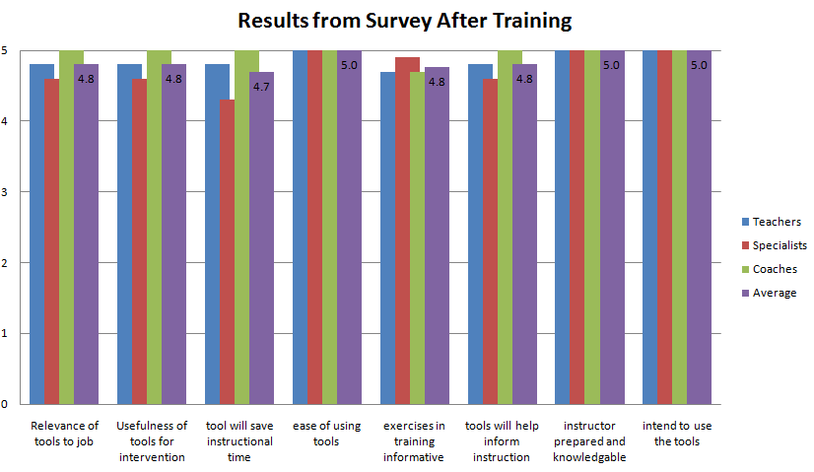
Figure 1: Bar Graph of Level I Survey Results After Training

Level 2 – Learning Results
- At the end of training, learners participated in a simulation exercise, and facilitators formally observed participants entering, printing, and selecting interventions and checked off competencies using an electronic performance checklist.
- Stakeholders anticipated learners would be able to complete at least 28/29 items on the performance checklist.
- All learners completed 27/29 correctly the first time through. Eleven learners needed help choosing the correct intervention by matching it to OS data. The learners were able to pass it on the second try.
- Coaches followed up with the two learners and continued to coach them on how to use the Observation Survey data to identify the correct intervention for a child.
Table 5: Results of Performance Check List
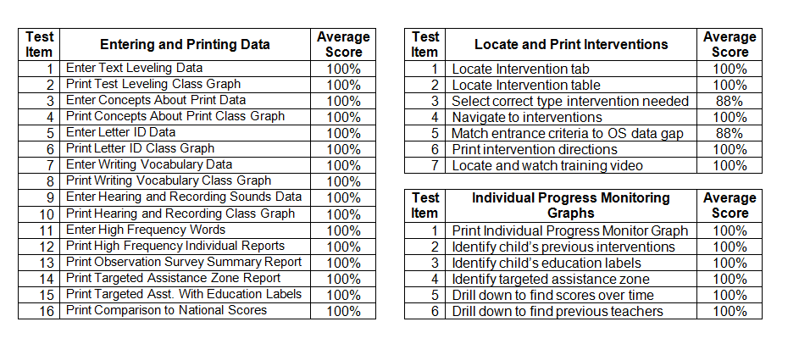

Level 3: Application Data
- Participants used a self assessment performance a check list when entering data the first quarter after training.
- When finished participants sent performance checklist to the coach to indicate the data was entered.
- The coach scored the checklist again to ensure data was all in correctly. All learners received a superior rating of 100% on data entry.
- 83% of learners used action plans in coaching. The coaching rubrics have not been tallied yet.

Level 4: Impact Data
The stakeholders had set rigorous goals for shifting student achievement data as a result of performance improvement in teachers’ ability to use data to differentiate instruction. The original goals were by the end of the 2009- 2010 instructional year:
  - Students in the does not meet expectations red zone (below 20th percentile nationally) will have reduced by 20% as measured by the Classroom Targeted Assistance Reports. After implementation the reduction was 51.83%.
  - Students in the yellow zone (below the 50th percentile nationally) will have reduced 20% as measured by the Classroom Targeted Assistance Reports. After implementation the actual reduction was 28.63%.
  - Students in the green and blue, meets and exceeds expectation zones will increase by 20%. After implementation the actual increase was 27.75%.
Table 6: Shifts in Students’ Targeted Assistance Zones After Implementation
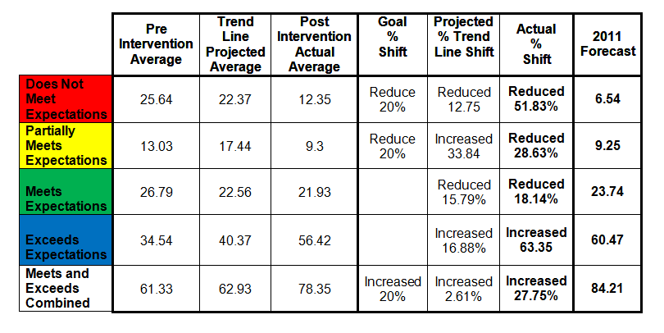

Level 4: Shifts in Trend Lines after Implementation

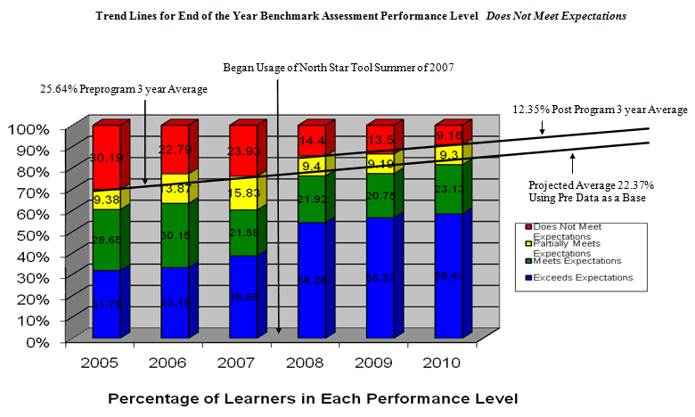
Figure 2: Trend Lines for End of the Year Benchmark: Does Not Meet Expectations

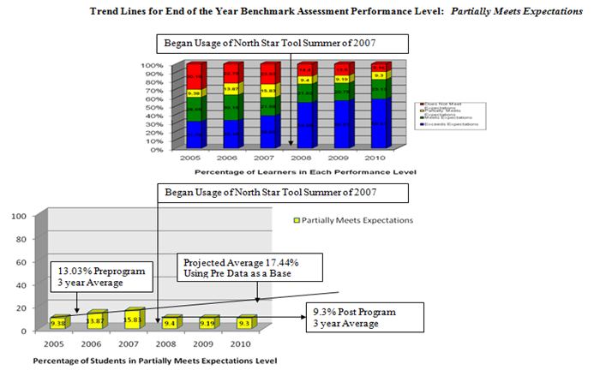
Figure 3: Trend Lines for End of the Year Benchmark: Partially Meets Expectations
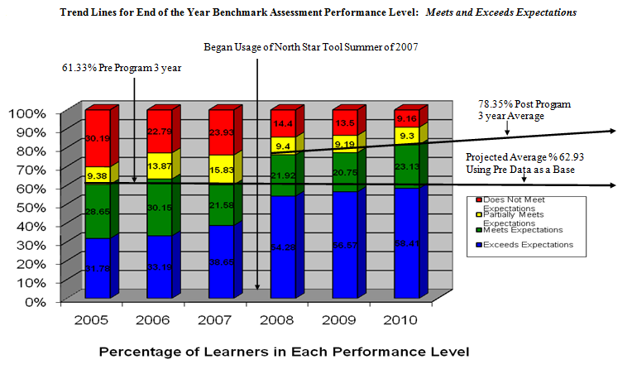
Figure 4: Trend Lines for End of the Year Benchmark: Meets and Exceeds Expectations

Methods for Converting Data to Money
Student achievement data was translated into monetary values by:
  - Multiplying the number of students in the red zone (below the 20th percentile nationally) with the cost of educating a special education student.

  - Multiplying the number of students in the multiplying the number of students in the red zone (below the 20th percentile nationally) with the cost of educating a Title I student

  - Students in the blue and green meets and exceeds columns were multiplied by the cost of educating a general education student.
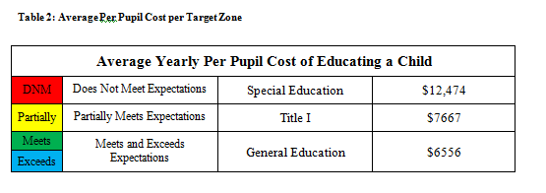
Table 7: Converting Data into Monetary Values
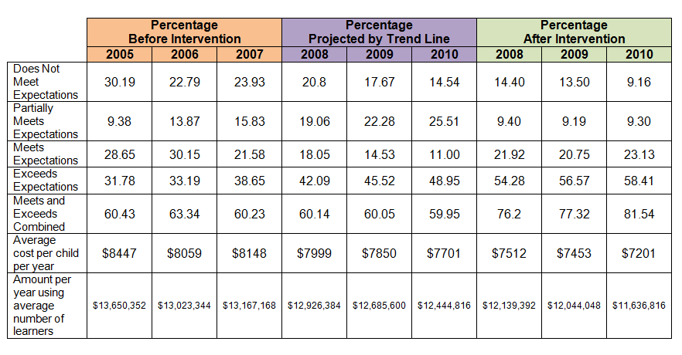

Total Program Costs
Table 8: Total Program Costs
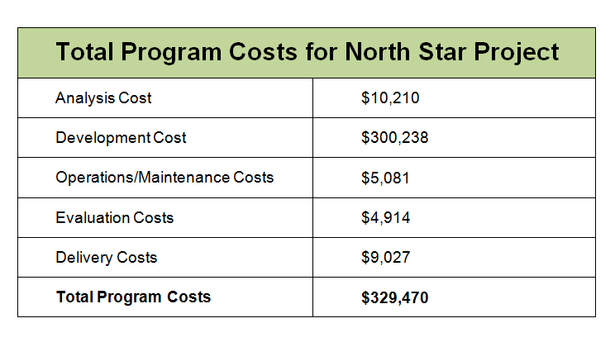

Total Impact of the Intervention
Table 9: Total Impact of Intervention
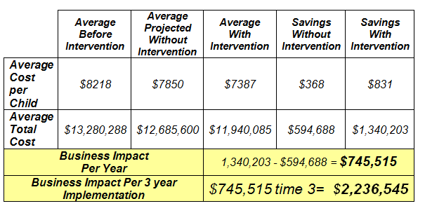

Level 5: Return on Investment of Implementation
The proposed return on investment was 25%. The implementation over three years’ time had a return on investment of 579%.

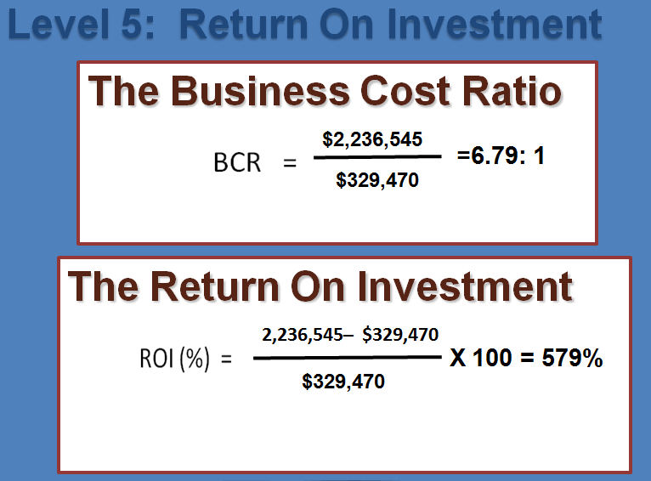
Figure 5: Return on Investment

ROI Business Impact Forecast for 2010-2011 School Year
Since the final report was presented in December of 2010. A forecast for the 2010-2011 school year was created (see Appendix Q for forecast). The forecast was projected from the trend lines drawn after implementation. The forecast was shared with the stakeholders along with the final report on December 13, 2010.

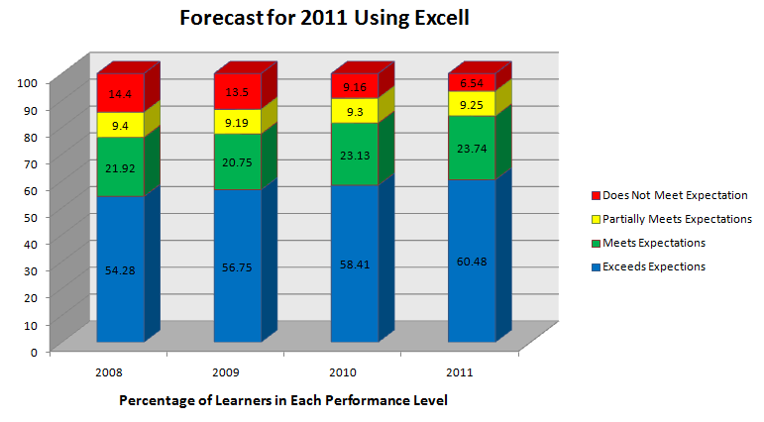
Figure 6: ROI Business Impact Forecast for 2011
Table 10: Converting Business Forecast Data into Money
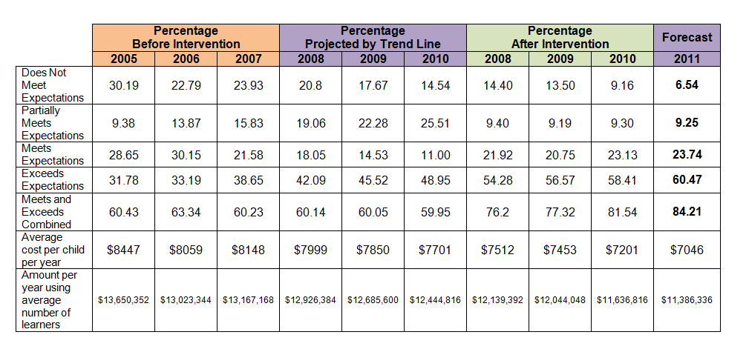

Action Plan for Improvement
Effective continuous improvement models ensure a process for ongoing evaluation and redesigning along the way. The North Star Electronic Improvement Support System was developed as an improvement plan for a paper pencil graphing system that was previously all teachers had. Tensions were rising before the implementation of the North Star Tool because of the amount of time needed to organize and hand graph the data, and the lack of its use. Two months were spent on the initial needs assessment, gap analysis, root cause analysis, and implementation selection. Several meetings happened early on to establish initial buy-in and support. Level 1 through Level 3 data were collected and reported within the first month of implementation. All three levels of data came back positive, and then three years were spent collecting impact data before the final ROI could be calculated.
During the initial stages of implementation the school district lost a levy referendum and had to cut over nine million dollars from the budget. Two schools were shut down and eight elementary schools full of staff and students were divided and placed into six buildings. Class sizes were high and morale low. Fifty four teaching positions were eliminated and two administrative positions were eliminated. Implementation of the project continued but staff, administration, parents and students were stressed. The two schools that were closed were the strongest at implementing the Literacy Collaborative and using the data to differentiate instruction. There were no silos at those two schools. General education teachers, special education teachers, Title I teachers, teaching assistants, and the coaches were a team. Legislators, university deans, and teams from school districts from around the United States would fly in to visit those schools and watch the high functioning Response to Intervention (ROI) model. When the schools were closed due to age and small size, the assistant superintendent said that the fire was burning bright at both schools. The district hoped that each staff member would pick up the torch from that fire and carry it over to another building and add it to the new fire so it would burn brighter. His prediction at the time was that the “phoenix would rise from the ashes.”
Before the restructuring, the special education leader was on board and very excited about the ability the teachers had to use data to differentiate instruction. He spoke nationally with the district trainer about the model. After the referendum failed and the schools closed, one of the strongest principals retired due to downsizing. The special education department took leadership teams from every building to a Response to Intervention conference in the fall of 2007 where everyone was told that the model that Brainerd was using was ineffective and that every child deserved a one-size-fits-all basal program. After returning from the conference, a couple of principals believed the speaker and were less supportive of the program, the coaches, and the coaching.
In 2008 the special education department sponsored the school leadership teams to attend the conference again. This time the preconference speaker and the keynote stated that Reading Recovery was ineffective and drained resources from the whole school district. Since this was the required first grade intervention for implementation, this made a very difficult implementation. During that same year, the fifth through eighth grade middle school began using the intervention mentioned by the conference as the one right way to measure student’s growth. The North Star tool was questioned when the other tool showed that half of the readers in fifth and sixth grade couldn’t read. The district trainer was instructed to conduct a study to explain why half of the students could not read and why there was no correlation between the new tool and the North Star data.
Over two thousand hours were spent by the Literacy Collaborative District Trainer and the District Reading Recovery Teacher Leader analyzing every aspect of student data in the district. The two studied Aims Web Data, North Star Benchmark Assessment Data, NWEA Map Test Data, and Minnesota Comprehensive Assessment state test data. After reading hundreds of research articles on each set of data, the trainers discovered that the Aims Web data was plotted on a bell curve, so there would always be half of the students that could not reach the target, because the target was the mean score for the district, and always grew to meet the new mean. Although the fifth and sixth grade teachers kept trying to teach the children to read faster, there were always half that couldn’t meet the goal, which kept changing to meet the new mean so there would always be half of the kids that couldn’t make it and half that could. AIMS Web was being used because it supposedly had predictive validity and could correctly predict how students would perform on the state test. When the AIMS Web scores and the state test comprehension scores were run through a correlation study, there was only a 27% correlation. A child could read at 80 words per minute or 240 words per minute and still score a high score of 22 on the comprehension section of the test. The same correlation was run with the 6th graders.
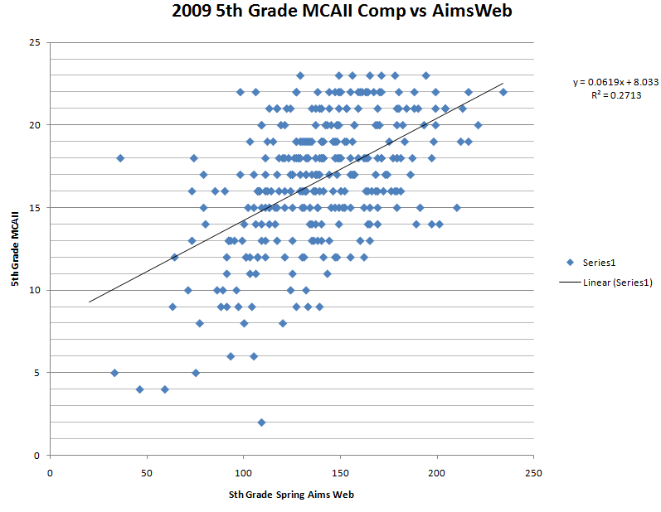
Figure 7: Lack of correlation between AIMS Web Scores and state test.
This was an important piece to show, because the number of students passing the Minnesota Comprehensive Assessment (MCA) state tests better matched the number of students passing in North Star. Both the state test and North Star showed a significantly greater number of children pass the state tests and the other indicator of the students doing well was that all elementary schools were making Adequate Yearly Progress (AYP) in No Child Left Behind.
Much time was spent on the study trying to discern the difference between the fifth and sixth grade teachers’ perceptions of the students and the perceptions primary teachers had when students left second grade. If teachers had simply been educated on the fact that the AIMS Web data was represented in a bell curve and so half of the students would always be above and half would always be below the mean. Teachers assumed the data meant a child’s ability to read, when it only measured the speed that a child read at. In future studies it is imperative that time is spent educating all stakeholders on the data and what it is representing.
This misinformation began trickling down to the intermediate teachers in third and fourth grade. In 2008 the third and fourth grade teachers stated that the students had never been lower on NWEA tests. Again another study commenced that actually showed that the most schools in the district had consistently maintained or raised the spring mean score of the NWEA tests over time. Only one school had fallen and that school had the biggest change in demographics after the schools closed and children shifted at the end of the 2007-2008 year. This study showed further disparity between the fall and spring scores and the fact that the actual growth targets far exceeded the expected growth targets generated by the company. The findings showed that there is a three month window to administer the tests in the fall and the spring. In the fall, Brainerd takes the NWEA test in the earliest window possible, yet Brainerd still exceeds the state mean for that time frame. In the spring, Brainerd takes the test in the last possible window. The recommendation was to take both tests during the middle month where the mean is calculated. This would make the NWEA scores more valid. Again time was spent explaining the data of another test, but never having an opportunity to explain the North Star data to the third through sixth grade teachers.
Table 11: NWEA Testing Data Over Time Study
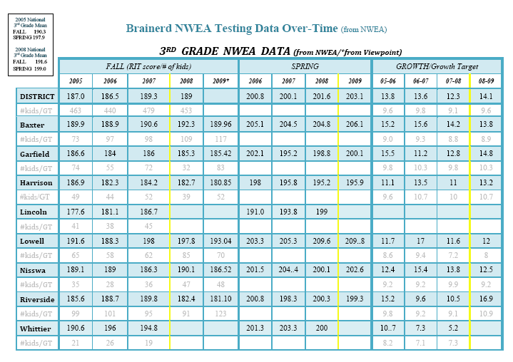
The biggest impact on the Return on Investment Project was the constant turn over in staff and administration over the three years of implementation. In 2007, right at the start of the project, the assistant superintendent who was the original vision holder for the project retired. The new assistant superintendent was the former high school principal and worked hard at reading and studying to get up to speed with the project. During the new assistant superintendent’s second year in office, the elementary curriculum coordinator retired and was replaced by the high school curriculum coordinator doubling her job to take on the elementary schools. One year later the superintendent resigned and the assistant superintendent took his place. The curriculum coordinator became one of two assistant superintendents, further stretching her responsibilities.
The state also instituted the Quality Compensation program that allowed districts to support professional learning communities (PLC) and pay teachers for learning. Although this supported the cost of coaching and PLC groups moving forward after the referendum failed, it also meant that the principals quit coming to PLC staff development on the Literacy Collaborative and quit reading the professional books. Principals no longer kept up to date on the theory or practice of the Response to Intervention initiative in K-2, and some did not hold teachers accountable to the reading and implementation as well. The hardest part was the administration did not know how to address the negative assertions from the intermediate and junior high teachers, because the principals didn’t know enough about the North Star data to help educate the teachers. When the new administration was challenged, instead of bringing everyone to the table to problem solve, people were kept separate and studies were run. In spite of these difficulties, the Literacy Collaborative initiative carried forward and had a very positive return on investment. The literacy coaches and district trainer filled out their yearend reports every spring studying the barriers and enablers in a continuous improvement format, and writing an annual report with an action plan for improvement that was followed the following year. By addressing these barriers and applying the solutions, Kindergarten through second grade teachers continued to gain momentum with their application of the data in differentiated instruction (see table 12 for interim barriers and solutions.)

Table 122: Interim Barriers that Were Solved During Implementation
Interim Barriers | Applied Solutions
Too much instructional time spent on assessment | Had a team of retired teachers travel around and assess and enter the data on North Star so teachers could keep teaching.
Hard to schedule plans for quarterly team meetings. | Had one sub travel from room to room implementing the same plan. Teachers were free to attend the quarterly meetings and focus on data instead of plans
Minutes for the meetings needed to be more timely. | Meeting minutes were typed directly into North Star and were available for all to access as soon as the meeting was finished.
Hard to wait until the next team meetings to see who has implemented action plans | Action plans are also on North Star and as people upload data plans and show results or completed projects, everyone can access and track as things are accomplished
People needed more clarification on roles, responsibilities and purpose of the ROI project | The entire implementation plan as well as a roles and responsibilities chart, and a glossary of terms were posted on North Star for web based access. Each time something was handed out at meetings copies were posted on North Star
Summary Data needed to be available each quarter. | Each monthly report that the District Trainer wrote was posted on North Star for all to access ongoing results.
Fear that the cost of the project and evaluation were too expensive and take money away from potential raises. | Revenues and expenditures were maintained and shown through a Power Point to the new superintendent, Director of Teaching and Learning, and the new Financial Director. Monthly update meetings were scheduled, but time didn’t allow for updates, but all records still were maintained and brought to every meeting by the district trainer.

In order to make an action plan for all other Return on Investment Studies, a final study happened to examine the Return on Investment process and identify over all barriers and enablers that could be addressed in an action plan for future Return on Investment studies. Many barriers that got in the way of implementation, as well as enablers that allowed the project to move forward were identified (see table 13).
Table 133: Barriers and Enablers
Barriers |  | Enablers
Level five ROI data was only calculated at the end of the entire three year program. It should have been calculated and communicated every year. |  | The K-2 coaches and teachers kept on coaching, reading, and learning, so implementation kept growing.
Data was only collected on Levels 1-3 at the beginning. It should have been continuously collected and tracked throughout the three year implementation. At least once a year |  | Informal surveys were collected every year at the end of PLCs that allowed the district trainer to address some of the concerns felt by the K-2 staff. See the interim barriers and solutions that happened during implementation in Table 12 below.
Level four data was only calculated at the end of the entire three year program. It should have been calculated and communicated every year. |  | Continued use of North Star so data informed instruction. Ongoing training for coaches so coaching and staff development stayed on the cutting edge.
Incorrect information passed without a way of problem solving. |  | Other districts began to use North Star so needed upgrades and use of the tool did not cost Brainerd any additional money.
No time spent doing a correlation study on the North Star Data with the state tests, as so much time had to be spent studying and educating stakeholders on other types of data. |  | The Director of Teaching and Learning changed data retreats from global district sessions to sessions at each school each quarter. This encouraged the principals to sit with the literacy Coordinators and look at the data for the schools and create action plans to shift issues of implementation
No time to train administrators who were the instructional leaders of the program. |  | When teachers learned the data was being looked at, teachers continued to collect and more rigorously taught using it.
 |  | The Director of Teaching and Learning learned how to read the data and helped problem solve implementation issues.

An additional tab is placed on North Star that allows stakeholders to share questions, concerns, and comments, as a proactive way to allow both supporters and critics to feel heard. It also is important to educate all stakeholders in advance of the intervention about the intervention and the ROI process to help cut down on misinformation being spread. Educating stakeholders on the ROI process can help them to be aware of the positive impact participation would have on the organization. Communicating the financial savings aspect of student achievement would help stakeholders realize that the benefits of participating as an active contributing member to improve student achievement not only would help the students, but it would free up valuable recourses for other programs. It is important that teachers and coaches do not see the measurement and evaluation as a personal evaluation of teaching, but more as an action research method of making them shine as teachers and coaches.
A detailed action plan (see Appendix O for action plan) was developed as a guide to improving measurement and evaluation for future Return on Investment Studies. The plan includes the different issues, actions that can be taken and the type of media that best addressed the issue. Four major agreements were made that will make all future Return on Investment (ROI) Projects flow more smoothly.
- Maintain short monthly meetings with leadership stakeholders to ensure communication is current and allow for problem solving.
- Bring all parties to the same table for problem solving and knowledge sharing to ensure effective continuous improvement.
- Gather Level 1 reaction and Planned Action Data throughout the project.
- Report quarterly results in Level 4 and Level 5 data throughout the project so results are transparent, instead of waiting for the end of the project.

Conclusions
The North Star Tool had a very strong Return on Investment (ROI) in spite of the barriers. The return was there because the District Trainer, the coaches and the elementary teachers carried on with implementation regardless of the barriers. There was little turn over in the coaches so the coaches were able to maintain the flow when the schools shifted. The North Star tool allowed for student data to automatically be sent to the student’s new school so although physical locations were moved, there was no interruption in application.
The rate of moving children from the at risk categories into meets and exceeds expectation was much higher, due to:
- Ease of organizing and sharing data.
- Differentiated instruction using the data.
- Teachers, specialists, and teaching assistants teaching all using the common data to plan interventions in data driven team meetings.
- Data being explained to parents, and specific things parents could work on with children were shared at conferences and in report cards.
- Assistants and specialists being assigned to classrooms by student need.
- The North Star tool actually became the hub that held the entire school reform initiative together throughout the three years of constant turmoil after the referendum failed.

Recommendations
Due to the success of the North Star Educational Tools Project in enabling teachers to accomplish the difficult task of differentiating instruction to meet the needs of all students, it is recommended that the tool be shared at conferences and colleges to continue to encourage educators to treat every child as an individual with individual learning needs. This study should be replicated in urban and suburban districts in various locations around the United States.

References
Chambers, J.G., Parrish, T. & Harr, J.J. (2002). What are we spending on special education services in the United States, 1999-2000? Palo Alto, CA: American Institutes for Research. Retrieved from, http://csef.air.org.

Clay, M. M. (2002). An observation survey of early literacy achievement (2nd ed.). Portsmouth, NW: Heinemann.

Forbes, S., Swenson, E., Person, T. (2008). Reading Recovery: A major component of many RtI models. Journal of Reading Recovery, Spring 2008, 53-56.

Fountas, I & Pinnell, G. S. (2005), Rubrics for formal observation in literacy collaborative classrooms. The Ohio State University: Columbus, OH.

Phillips, J.J. & Aaron, B.C. (2008). Isolation of results: Defining the impact of the program. In Phillips, J.J., & Phillips, P.P. (Eds.), ROI fundamentals: The measurement & evaluation series (Vol. 3). San Francisco, CA: Pfeiffer.

Phillips, P.P. & Burkett, H. (2008). Data conversion: Calculating the monetary benefits. In Phillips, J.J., & Phillips, P.P. (Eds.), ROI fundamentals: The measurement & evaluation series (Vol. 4). San Francisco, CA: Pfeiffer.

Phillips, J. J., & Phillips, P. P. (2007a), Show me the money: How to determine ROI in people, projects, and programs. San Francisco, CA: Berrett-Koehler publishers, Inc.

Phillips, J.J., & Phillips, P.P. (2007b). The value of learning: How organizations capture value and ROI. San Francisco, CA: John Wiley & Sons, Inc.

Phillips, J.J., & Phillips, P.P. (2008a). Beyond learning objectives: Develop measurable objective that link to the bottom line. Birmingham, AL: ASTD Press.

Phillips, P.P. & Phillips, J.J. (2008b). ROI fundamentals: Why and when to measure return on investment. In Phillips, J.J., & Phillips, P.P. (Eds.), ROI fundamentals: The measurement & evaluation series (Vol. 1). San Francisco, CA: Pfeiffer.

Phillips, J.J., & Phillips, P.P. (2010). Measuring for success: what CEOs really think about learning investments. Alexandria, Virginia: ASTD Press.

Phillips, P.P. & Stawarski, C.A. (2008). Data collection: Planning for and collecting all types of data. In Phillips, J.J., & Phillips, P.P. (Eds.), ROI fundamentals: The measurement & evaluation series (Vol. 2). San Francisco, CA: Pfeiffer.

Phillips, P.P. & Tush, W.F. (2008). Communication and implementation: Sustaining the practice. In Phillips, J.J., & Phillips, P.P. (Eds.), ROI fundamentals: The measurement & evaluation series (Vol. 6). San Francisco, CA: Pfeiffer.
Phillips, P.P. & Zuniga, L. (2008). Cost and ROI: Evaluation at the ultimate level. In Phillips, J.J., & Phillips, P.P. (Eds.), ROI fundamentals: The measurement & evaluation series (Vol. 5). San Francisco, CA: Pfeiffer.

Swenson, E. (2007). North Star Educational Tools (web-based data collection software). www.northstaret.com.

US Department of Education. (2002). Fiscal year 2002 Title I grants to local education agencies: Minnesota. Retrieved from http://www2.ed.gov/about/overview/budget/titlei/fy02/Minnesota.pdf

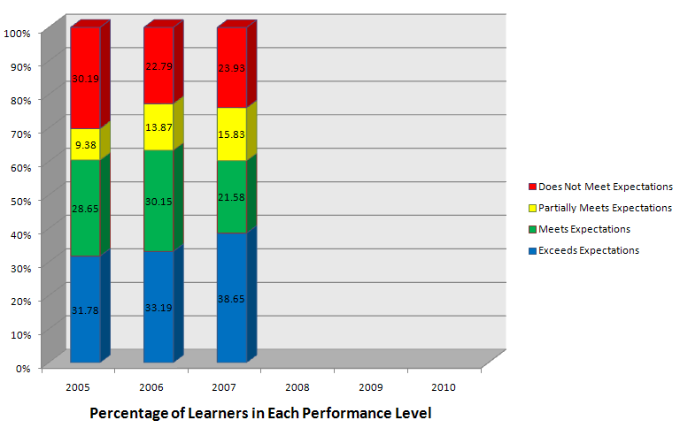
Appendix A: Baseline Data

Number of Students in Each Performance Range for First Three Years of the Program

Figure 8: Baseline data
Does Not Meet Expectations students: below the national 20th percentile- special education
Partially Meets Expectation students: below the national mean – Title I
Meets Expectation students: above the mean to high benchmark– General Education
Exceeds Expectation students are above high benchmark – General Education

Appendix B: Gap Analysis
Table 14: Gap Analysis results from data compiled from data brought to the focus session.
Process or Activity | Expected  Performance | Current  Performance | Performance  Gap | Effect on District
Teachers should be implementing the entire literacy collaborative frame work. | 85% teachers are implementing the full frame work. | Coaching notes indicate 74% of teachers are using the full framework | 11% | Teachers will not see the same growth in student achievement if not using all of the parts of the framework.
Teachers should bring student data to every coaching session to inform coaching and instruction | 85% of the teachers should be bringing data to the coaching sessions. | 24% of teachers are bringing data to the coaching sessions | 61% | Coaching sessions will not be as effective if data is not present for teachers to learn how to use it for teaching for shifts in student understandings.
Teachers should use data to teach from on a daily basis | 85% of the teachers should be using data to teach from on a daily basis. | Only 12% of teachers indicated in coaching conferences that data is used to teach from on a daily basis. | 73% | Teachers are teaching curriculum and not differentiating it to meet students’ learning needs.
Teachers should share data with teaching assistants and specialists so all are using the same data to teach from. | 85% of the teachers should be sharing data with specialists and teaching assistants. | Only 12% of teachers indicated sharing data with specialists. | 78% | Classroom teachers, specialists, and teaching assistants are not sharing data so instruction is not aligning and student achievement gaps are not closing rapidly.

Focus | Stakeholders | Informational Needs | Expectations and Priorities
Process Focus Results Focus | Teachers are interested in: | - content of the interventions  - purpose of the interventions  - performance expectations for each intervention. | Teachers expect to be kept informed about the interventions and the impact. Teachers expect to be supported with implementation throughout the interventions.
Process Focus Results Focus | Literacy Coaches are interested in: | - content of the interventions  - purpose of the interventions  - performance expectations for each intervention.  - detailed Information to guide the implementation | Literacy coordinators have high expectations that teachers were engaged and prepared. Literacy Coordinators have expectations that every teacher will finish the pre-assessment, and were responsive to coaching and training,
Process Focus Results Focus | School Principals are interested in: | - content of the interventions  - purpose of the interventions  - performance expectations for each intervention.  - What is happening with the intervention  - Ways to hold participants accountable | The expectation and priority that all teachers will learn to teach comprehending through fluency. Principals have high expectations that coaching and staff development will raise student achievement.
Process Focus Results Focus | Director of Teaching and Learning and District trainer is interested in: | - purpose of the interventions  - whether interventions were appropriate  - accomplishment of goals  - Disaggregated performance information by school.  - Variations from expected results | The Director of Teaching and Learning has the expectation that teachers will hone interrater reliability on fluency scoring, insuring that teaching data is correct, and that all teachers will succeed in learning how to teach comprehending through fluency.
Process Focus Results Focus | Superintendent and  School Board are interested in: | - impact of the interventions on the school district.  - accomplishment of district goals  - A synthesis of information for implications.  - Information about performance at the district level | The superintendent and school board have high expectations that the schools will raise student achievement scores and make adequate yearly progress (AYP).
Process Focus Results Focus | Parents are interested in: | - Outcomes of intervention on student achievement data  - Teachers sharing information from training and coaching interventions so parents can follow through with shifts in teaching while reading with child at home. | Parents have high expectations that the teachers of the children will learn to effectively teach children comprehension through fluency. Solving the declining student achievement issue is a high priority for parents.
Process Focus Results Focus | Students are interested in: | Students do not need information about the intervention or evaluation process. | Students have the expectation that all teachers will learn how to teach them fluency. Since research shows that fluency, especially phrasing, leads to higher comprehension, students have a high expectation the teacher will learn to teach fluency.

Appendix C: Stakeholders
Table 4: Stakeholder Communication Needs

Appendix D: Objectives and Data Collection Plan
Table 15: Objectives and Data Collection Plan
Evaluation Purpose: To determine the impact of the North Star Educational Tools Electronic Performance Support System using
Return on Investment Methodology.
Program: North Star Educational Tools EPSS Responsibility: Elizabeth A. Swenson Date: July 20, 2010
Level | Broad Program Objective(s) | Measures | Data Collection Method/Instruments | Data Sources | Timing | Responsibilities
Level 1 | - By the end of the training session participants will indicate the content of the training was important and relative to the success of differentiated instruction and indicate a strong intent to use the electronic performance support system (EPSS). | Scoring an overall average of at least  4 out of 5 on a 5 point Likert scale | Questionnaire  The questionnaire will contain 8 formal measurable questions using a 5 point Likert scale for the ROI study, as well as 2 informal open ended questions for indications of barriers, enablers, and intangibles. | participants | Baseline data Closing of Aug. 25th, 2011 training session  Follow up data  May 17, 2012 | Training facilitator
Level 2 | - By the end of the training class, participants will demonstrate correctly entering and printing student data using the training simulation exercise on North Star Educational Tools electronic performance support system (EPSS). | Scoring 16/16 on section one of the observation check list | Formal Observation with Performance Check List. The checklist was an electronic measurement tool with 16 measures. A check box was ticked upon successful demonstration of each measure. | Participants  coaches | Baseline data Closing of Aug. 25th, 2011 training session  Follow up data  May 17, 2012 | Training Facilitator,  coach
Level 2 | - By the end of the training class, will demonstrate through using the training simulation exercise, the ability to locate and print and intervention that matches the area of need indicated on the observation survey summary report. | Scoring 6/6 on section two of the performance checklist | Formal Observation with Performance Check List. The checklist was an electronic measurement tool with 6 simulations. A check box was ticked upon successful demonstration of each measure. | Participants  coaches | Baseline data Closing of Aug. 25th, 2011 training session  Follow up data  May 17, 2012 | Training Facilitator,  Coach
Level 2 | - By the end of the class, participants will demonstrate the ability to print a signal child’s progress monitoring graph and correctly identify the child’s previous interventions, education labels, and targeted assistance zone in a training simulation exercise. | Scoring 4/4 on section three of the performance check list. | Formal Observation with Performance Check List. The checklist was an electronic measurement tool with 4 measures. A check box was ticked upon successful demonstration of each measure. | Participants  coaches | Baseline data Closing of Aug. 25th, 2011 training session  Follow up data  May 17, 2012 | Training Facilitator,  Coach
Level 3 | - By the first quarterly test due date following the training, and every quarter afterwards, participants will correctly enter quarterly benchmark data. | Scoring 9/10 on the performance check list. | Participant will fill out the performance check list as data is entered, sending the completed for to the coach. The coach will also score the check list. | participants | Sept. 9,  2007 | Training Facilitator,  Coach
Level 3 | - Participants will demonstrate correct use of the data during teaching, using an appropriate balanced literacy tool to teach for a shift, as measured by 7 out of 10 on data analysis and coaching rubrics. | 7 out of 10 on data analysis and coaching rubrics | Formal Coaching Rubric (Fountas & Pinnell, 2005)  Running Records (Clay, 2002) | participants  coaches | By June 1, 2010 | Training Facilitator,  Coach
Level 4 | - By the end of the instructional year, Kindergarten through second grade Special education numbers will have decreased by 20% | Reduced by 20% | North Star Educational Tools Targeted Assistance Zone with Education Labels report  trend line | Paul Bunyan Co-op Records | By June 1, 2010 | Coach/teacher
Level 4 | - By the end of the instructional year, students in the red zone (below 20th percentile) will have reduced by 20%, as measured by the Classroom Targeted Assistance Reports (CTAS). | reduced by 20% | North Star Educational Tools Targeted Assistance Zone report  trend line | coach,  teacher,  principal,  Trainer | By June 1, 2010 | District Trainer
Level 4 | - By the end of the instructional year, students in the yellow zone (below 50th percentile) will have reduced by 20%, as measured CTAS. | reduced by 20% | North Star Educational Tools Targeted Assistance Zone report  trend line | coach,  teacher,  principal,  Trainer | By June 1, 2010 | District Trainer
Level 4 | - By the end of the instructional year, students in the green (mean) and blue (above high benchmark) zones will increase by 40%, as measured by CTAS. | increased by 20% | North Star Educational Tools Targeted Assistance Zone report  trend line | coach,  teacher,  principal,  Trainer | By June 1, 2010 | District Trainer
Level 5 | - By the end of the current school year, and based on one year of value, the project will attain a benefit-cost ratio of 1.25:1 and represent an ROI value of 25 %, using the first year of benefits. | Baseline Data:  Trend line of numbers of children in red (does not meet expectations), yellow (approaching expectations), green (meets expectations) and blue zones (exceeds expectations).
Level 5 |  | Comments:
- © 2006 ROI Institute. All rights reserved. Adapted with permission by Beth Swenson 2010

Appendix E: Trend Lines for End of the Year Benchmark Assessment Performance Level: Does Not Meet Expectations
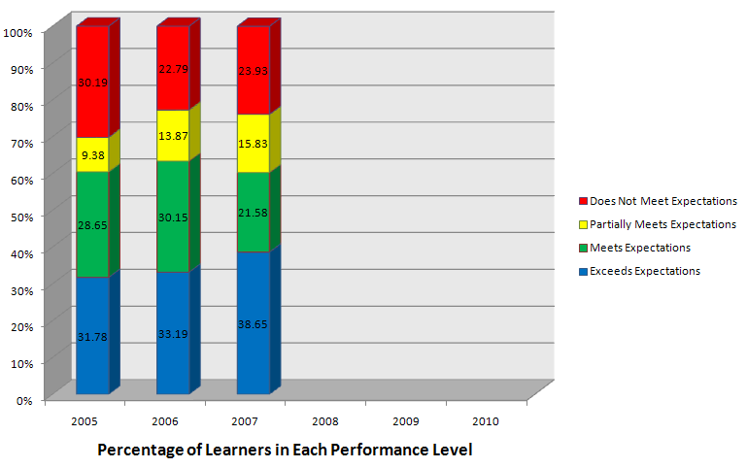
25.64% Pre Intervention Average

Projected Average 22.37%

Figure 9: Projected Trend Lines for Does Not Meet Expectations

Appendix F: Standardized Cost of Educating a Special Education Versus General Education Student in 2000
According to Special Education Expenditure Project (SEEP)
General Education has been double the cost of Special Education from 1968 – 2000

Figure 10: Standardized Values for Cost of Educating Special Education Student and General Education Student

Appendix G: Trend Lines for End of the Year Benchmark Assessment Performance Level: Partially Meets Expectations
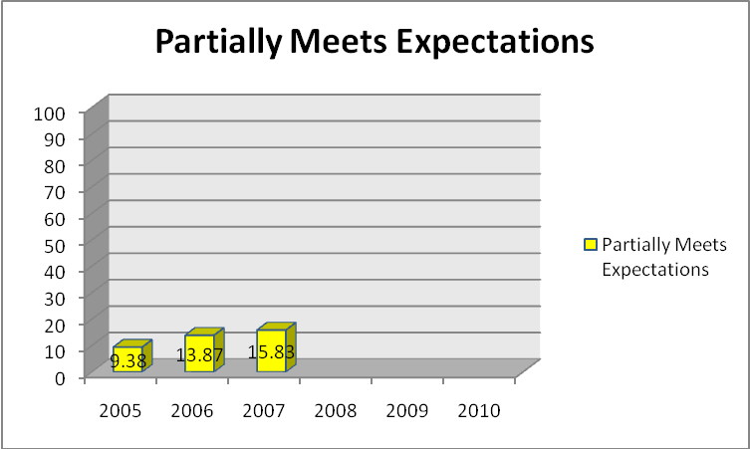
The partially meets portion of the stacked bar graph was taken out and blow up to allow for a flat base in order to draw the trend line.
Projected Average 17.44%
Using Pre Data as a Base
13.03% Preprogram
3 year Average

Figure 11: Projected Trend Lines for Partially Meet Expectations

Appendix H: Standardized Cost for Educating a Title I student in Brainerd, MN in 2002
Table 16: Standardized Cost for Educating a Title I student

Appendix I: Trend Lines for End of the Year Benchmark Assessment Performance Level: Meets and Exceeds Expectations
Projected Average 62.93%
Using Pre Data as a Base
61.33% pre intervention average of children meeting or exceeding benchmark

Figure 12: Projected Trend Lines for Meets and Exceeds Expectations

Appendix J: Job Aid: Steps to Determine the Most Feasible Method(s) of Isolation
Step One: Step Two:
The timeframe must be sufficient to allow for performance change and normal influences in the operational environment.
Select one of the L-4 measures that your program should influence.
The measure is:

Increasing the number of students in the meets and exceeds benchmark performance levels. Decreasing the numbers of kids in the partially meets and does not meet categories.
Identify the timeframe necessary to monitor progress and collect data to determine how the selected measure has changed?
The timeframe is:

6 years: three years to set trend line before the intervention, and three to measure impact after implementation.

Step Three:
Identify the key internal and external factors that could influence the measure in the performance setting during the established time frame (apply the 80/20 Rule). The factors are:
A) change in student population | D) Change in program  (drop coaching) | G)
B) employee turn over | E) Change in program  (drop staff development) | H)
C) Change in curriculum | F) Change in Leadership | I)
Who is best positioned to know and assist in identifying these factors? Seek their input.

Step Four:
Yes
Is it feasible to establish a control group arrangement?

No
Consider logistical issues, ethical issues, contamination issues, etc., and ability to withhold the solution considering the time frame in Step Two.

Can a trend be established from historical performance data on the selected measure and are the criteria for using trend analysis or forecasting methods met?
Use control group arrangement
to isolate the effects.

Considering the factors from step three, establish the control group criteria. Select the control & experimental groups by matching the factors that meet the criteria. Who is best positioned to know how the factors from step three may influence the measure? Ask them to assist in the control group design.

No
Yes

Use trend line or forecasting methods to isolate the effects.
Use estimates from participants or other sources to isolate the effects.

Identify who is best positioned to provide estimates on the impact of the training and other influencing factors from step three. Ask: are they positioned to know, are they credible, and will they cooperate?
If using trend analysis, be certain there are no other influencing factors. If using forecasting, verify the appropriate mathematical relationship with other influencing factor(s).

Appendix K: Isolation Selection Tool
Table 17: Isolation Selection Tool
 | Isolation Methods | Feasible Because… i.e. Strengths | Not Feasible Because… i.e. Weaknesses
1 | Control groups | Could be done with matched pairs. | In education it is difficult to have schools commit to several years of not using a tool (control group) that could help kids.
2 | Trend line analysis | Everything in education is measured with trend lines. The data would be easy to collect and graph. Trend lines measure performance data, and teaching and learning both produce tremendous amounts of performance data over time. | Many other variables could cause shifts in data, so trend data must be cross checked with performer’s estimate of impact to verify the percentage of the total shift that is due to the intervention.
3 | Forecasting methods | If other factors arise, a trend line is no longer feasible. Forecasting would be appropriate as it could account for the additional variables. | Not needed unless other factors arise.
4 | End user’s/performer’s estimate of impact (percent) | Easy to do, and will lend credibility to the trend line. | Make sure the feedback is anonymous to ensure it is not tainted.
5 | Supervisor’s estimate of impact (percent) | Easy to use/inexpensive | Supervisors are too removed from the daily teaching to know what impacts teachers.
6 | Management’s estimate of impact (percent) | Easy to use/inexpensive | Senior management is even farther removed from classrooms than supervisors.
7 | Use of experts/previous studies | Previous studies were used to obtain conservative standardized values of the cost of educating special education, Title I and General Education Students. | Finding standardized estimates for each year is not feasible with limited resources. Very conservative baseline data of 2000 and 2002 standardized values were used throughout the project.
8 | Calculate/estimate the impact of the other factors | Would help to isolate the effects of the tool if other factors arise. | Not needed unless other factors arise, then a less expensive forecasting method would be implemented.
9 | Customer inputs | Not applicable | Other North Star Customers may have different interventions in place, so the data will not be applicable to Brainerd.
2005 Table copy permission by developer K. Minchella, Ph.D.

Appendix L: Cost Estimating Worksheet
Table 18: Cost Estimating Worksheet
Cost Estimating Worksheet
Analysis Costs |  |  |  | Total
Salaries and Employee Benefits--HRD Staff (No. of People x Average Salary x Employee Benefits Factor x No. of Hours on Project) |  |  |  | $9850
Meals, Travel, and Incidental Expenses
Office Supplies and Expenses
Printing and Reproduction
Outside Services |  |  |  | $360
Equipment Expenses
Registration Fees
Other Miscellaneous Expenses
Total Analysis Cost |  |  |  | $10,210
Development Costs |  |  |  | Total
Salaries and Employee Benefits (No. of People x Avg. Salary x Employee Benefits Factor x No. of Hours on Project) |  |  |  | $74,898
Meals, Travel, and Incidental Expenses
Office Supplies and Expenses |  |  |  | $150
Program Materials and Supplies |  |  |  | $600
Printing and Reproduction
Outside Services |  |  |  | $224,440
Equipment Expenses
Other Miscellaneous Expenses |  |  |  | $150
Total Development Costs |  |  |  | $300,238
Delivery Costs |  |  |  |  |  | Total
Participant Costs, Salaries & Employee Benefits: No. of Participants X Avg. salary X Employee benefits factor X Hours or Days of training time |  |  |  |  |  | $2627__
Meals, Travel, and Accommodations (No. of participants X Avg. daily expenses X Days of training)
Program Materials and Supplies |  |  |  |  |  | $600
Participant Replacement Costs (if applicable)
Lost Production (Explain Basis)
Facilitator Costs |  |  |  |  |  | $5480
Salaries and Benefits |  | $5480
Meals, Travel, and Incidental Expenses
Outside Services
Facility Costs |  |  |  |  | $320
Facilities Rental
Facilities Expense Allocation | $320
Equipment Expenses (offsite, part of development expenses)
Other Miscellaneous Expenses
Total Delivery Costs |  |  |  |  | $9027
Operations/Maintenance |  |  |  |  | Total
Salaries and Employee Benefits--HRD Staff (No. of People x Avg. Salary x Employee Benefits Factor x No. or Hours on Project) |  |  |  |  | $411
Meals, Travel, and Incidental Expenses (to conferences for marketing) |  |  |  |  | $2,600
Participant Costs
Office Supplies and Expenses |  |  |  |  | $150
Printing and Reproduction (Brochures/ Ad) |  |  |  |  | $570
Outside Services (Web site license fees) |  |  |  |  | $150
Equipment Expenses |  |  |  |  | $1200
Other Miscellaneous Expenses (Tables at conferences)
Total Operations/Maintenance Costs |  |  |  |  | $5081
Evaluation Costs
Salaries and Employee Benefits--HRD Staff (No. of People x Avg. Salary x Employee Benefits Factor x No. or Hours on Project)  40hrX 1personX$18/hr =  10hrX8 peopleX$18= |  |  |  |  | $2160
Meals, Travel, and Incidental Expenses
Participant Costs 54 peopleX1 hrX $18 |  |  |  |  | $972
Office Supplies and Expenses |  |  |  |  | $75
Printing and Reproduction (online)
Outside Services (online surveys) |  |  |  |  | $360
Equipment Expenses
Other Miscellaneous Expenses ($1347) |  |  |  |  | $1347
Total Evaluation Costs |  |  |  |  | $4914
General Overhead Allocation |  |  |  |  | $324,556
TOTAL PROGRAM COSTS |  |  |  |  | $329,470

Appendix M: Converting Trend Line Data to Monetary Values

Key For Calculations
Table 2: Average Per Pupil Cost per Target Zone
Average Yearly Per Pupil Cost of Educating a Child
DNM | Does Not Meet Expectations | Special Education | $12,474
Partially | Partially Meets Expectations | Title I | $7667
Meets | Meets and Exceeds Expectations | General Education | $6556
Exceeds | Meets and Exceeds Expectations | General Education | $6556

Table 19: 2004-2005 Actual Student Cost Per Targeted Assistance Zone
2004 – 2005 Student Cost Per Targeted Assistance Zone
Proficiency Levels | Percent of Children | Number of Children | Cost to Educate for One Year
Does Not Meet | 30.19 | 473 | $5,900,202
Partially Meets | 9.38 | 147 | $1,127,049
Meets | 28.65 | 449 | $2,943,644
Exceeds | 31.78 | 498 | $3,264,888
Total | 100 | 1567 | $13,235,783
Average cost per student $13,235,783 ÷ 1567 = $8447

Table 20: 2005-2006 Student Cost Per Targeted Assistance Zone
2005 – 2006 Student Cost Per Targeted Assistance Zone
Proficiency Levels | Percent of Children | Number of Children | Cost to Educate for One Year
Does Not Meet | 22.79 | 368 | $4,590,432
Partially Meets | 13.87 | 224 | $1,717,408
Meets | 30.15 | 487 | $3,192,772
Exceeds | 33.19 | 536 | $3,514,016
Total | 100 | 1615 | $13,014,578
Average cost per student $13,014,578 ÷ 1615 = $8059

Table 21: 2006-2007 Student Cost Per Targeted Assistance Zone
2006-2007 Student Cost Per Targeted Assistance Zone
Proficiency Levels | Percent of Children | Number of Children | Cost to Educate for One Year
Does Not Meet | 23.93 | 387 | $4,827,438
Partially Meets | 15.83 | 256 | $1,962,752
Meets | 21.58 | 349 | $2,288,044
Exceeds | 38.65 | 625 | $4,097,500
Total | 100 | 1617 | $13,175,734
Average cost per student $13,175,734 ÷ 1617 = $8148

Table 22: Calculating average number of students per year to use for projections
Year | Average Number of Students
2004-2005 | 1567
2005-2006 | 1615
2006-2007 | 1617
Average | 1600

Table 23: 2007-2008 Projected Student Cost Per Targeted Assistance Zone
2007-2008 PROJECTED Student Cost Per Targeted Assistance Zone
Proficiency Levels | Percent of Children | Number of Children | Cost to Educate for One Year
Does Not Meet | 20.8 | 333 | $4,153,842
Partially Meets | 19.06 | 305 | $2,338,435
Meets | 18.05 | 289 | $1,894,684
Exceeds | 42.09 | 673 | $4,412,188
Total | 100 | 1600 | $12,799,149
Average cost per student $7999 (rounded)

Table 24: 2008-2009 Projected Student Cost Per Targeted Assistance Zone
2008-2009 PROJECTED Student Cost Per Targeted Assistance Zone
Proficiency Levels | Percent of Children | Number of Children | Cost to Educate for One Year
Does Not Meet | 17.67 | 283 | $3,530,142
Partially Meets | 22.28 | 356 | $2,729,452
Meets | 14.53 | 233 | $1,527,548
Exceeds | 45.52 | 728 | $4,772,768
Total | 100 | 1600 | $12,559,910
Average cost per student $7850 (rounded)
Table 25: 2009-2010 Projected Student Cost Per Targeted Assistance Zone
2009-2010 PROJECTED Student Cost Per Targeted Assistance Zone
Proficiency Levels | Percent of Children | Number of Children | Cost to Educate for One Year
Does Not Meet | 14.54 | 233 | $2,906,442
Partially Meets | 25.51 | 408 | $3,128,136
Meets | 11.00 | 176 | $1,153,856
Exceeds | 48.95 | 783 | $5,133,348
Total | 100 | 1600 | $12,321,782
Average cost per student $7701 (rounded)

Table 26: Pre Intervention Average Cost Per Child
Pre intervention PROJECTEDAverage Student Cost Per Targeted Assistance Zone
Proficiency Levels | Percent of Children | Number of Children | Cost to Educate for One Year
Does Not Meet | 25.64 | 410 | $5,114,340
Partially Meets | 13.03 | 208 | $1,594,736
Meets | 26.79 | 429 | $2,812,524
Exceeds | 34.54 | 553 | $3,625,468
Total | 100 | 1600 | $13,147,068
Average cost per student $8217 (rounded)

Table 27: Projected 3 Year Average Per Child
Post Intervention PROJECTED Average Student Cost Per Targeted Assistance Zone
Proficiency Levels | Percent of Children | Number of Children | Cost to Educate for One Year
Does Not Meet | 22.37 | 358 | $4,465,692
Partially Meets | 17.44 | 279 | $2,139,093
Meets | 19.82 | 317 | $2,078,252
Exceeds | 40.37 | 646 | $4,235,176
Total | 100 | 1600 | $12,918,213
Average cost per student $8074 (rounded)

Appendix N: Results Communication Plan
Table 28: Results Communication Plan
Project  Phase | Stakeholders:  Target Audience | Key Message | Objective | Approach | Frequency | Responsibility | Comments/  Concerns
Roll out | Superintendent and school board | Value of ROI  Appreciation of results based measures | Approval of intervention, sponsorship granting resource | Leadership Meeting  face to face | July 14, 2007 | District Trainer | Educate Supt on the process of ROI and the impact on district
Roll out | Principals | Value of ROI  Impact on teams | Gain support. | Leadership Meeting  face to face | July 28, 2007 | District Trainer | Educate Supt on the process of ROI and the impact on district
Roll out | Teachers and Coaches | Value of ROI  Impact on kids and teams | Gain support and address needs or issues | News Letter, Power Point | August 25, 2007 | District Trainer and Coaches | Educate them on the process of ROI and the impact on district
Evaluation Planning | principals  Director of Learning  District Trainer | Needs Assess.  Gap Analysis  Performance Issues | Explain Needs Assessment  Gap Analysis  Performance Issues | Discussion face to face | August 4  Sept 18 | District Trainer | Use online survey  Analyze results
Data Collection | All Stakeholders | Follow up Questionnaire | Gather Follow up data for levels 1 - 2 | Questionnaire  Reported at June 8th Meeting | Baseline Aug. 25th, 2007 Follow up  May 17, 20107 | District Trainer | Levels 1 and 2 data collection and analysis
Data Collection | Superintendent  Principals  Dir. of Teaching  District Trainer | Initial and ongoing findings | keep informed  so able to encourage other stakeholders | Face-to-face  power point and  Web presentations of data and impact | Sept 22,2007  Dec 8, 2007  March 8, 2008  June 7, 2008 | District Trainer | Fidelity of collection  how to have team meetings to analyze
Data Collection | Teachers and Coaches | fidelity  analysis  action research | review data  analyze  action plan  coach | 2 hr Training  August 25, 2011  Team meetings (1.5 hr per class) | Sept 22,2007  Dec 8, 2007  March 8, 2008  June 7, 2008 | District Trainer | Logistics, Fidelity of collection, Team meetings to analyze,  Levels 3-4 analysis
Reporting Results | Superintendent and school board | report success | communicate results, seek support for ongoing revision | 1 hr meeting  Power Point and discussion | Dec, 13, 2010 | District Trainer | make sure to be conservative and re-explain ROI process.
Reporting Results | Director of Teaching and Learning  Principals | report success  seek feedback | communicate results, seek more input for future revisions | Face-to-face  Power point  ongoing blog | end of program reporting on all 5 levels Dec, 13, 2010 | District Trainer | gather and analyze new needs assessment data
Reporting Results | Teachers and Coaches | report success  seek feedback | communicate results, seek more input for future revisions | Face-to-face  Power point  ongoing blog | end of program reporting on all 5 Dec, 13, 2010 | District Trainer | How did it impact efficacy, stress, gather new needs assessment data

Appendix O: Action Plan for Improvement
Table 29: Action Plan for Improvement
Action Plan for Improvement
Develop a plan of implementation for improving measurement and evaluation in your organization. Consider all of the items included in all modules. Identify a particular time frame and key responsibilities.
Issue | Actions | Media Selection | Time | Responsibility
1. Perception of HR | Deliver Power Point that shows the benefits for the District Trainer’s role in the project | Power Point and discussion with stakeholder leadership team/ | May 8, 2010 | District Trainer
2. Needs assessment/ analysis | Gather data and analyze issues stakeholders are having with project. | Online survey, informal interviews, focus groups | May 8, 2010 | District Trainer  Stakeholders meeting.
3. Objectives | Develop Objectives together | face-to-face work session with stakeholders | May 16, 2010 | District Trainer  Stake holder team
4. Reaction measures | 5 point scale likert questionnaire. Meet as a team and analyze results | questionnaires and focus groups | May 16, 2010 | District Trainer
5. Learning measures | review quarterly data and action plans, and reflections. | team meetings, coaching action plans | May 23, 2010 | District trainer
6. Application measures | Review North Star data to see shifts in student achievement. | team meeting, action plan and implementation, north star | May 23, 2010 | District Trainer  Director of teaching and learning,  Coaches
7. Impact measures | Review North Star Benchmark Data | Power Point, and North Star | May 23, 2010 | District Trainer  Director of teaching and learning,  Coaches  Leadership team
8. ROI measures | Conduct ROI analysis | Data, North Star, costs work sheets | May 23, 2010 | District trainer and coaches
9. Use of technology | use existing computer lab  develop and implement training on north star | computer lab, smart board, mobi, | May 28, 2010 | District Trainer and coaches
10. Communicating results | create ROI finished Study, create executive summary or ews articles | work sessions with coaches  face-to-face presentation to stakeholders. Executive summaries sprinkled in waiting rooms around town | Dec 13th, 2010  Dec 13th, 2010 | District Trainer and Coaches

Appendix P: End of Program Calculated Amounts
Key For Calculations
Table 2: Average Per Pupil Cost per Target Zone
Average Yearly Per Pupil Cost of Educating a Child
DNM | Does Not Meet Expectations | Special Education | $12,474 | Chambers, J.G., Parrish, T. & Harr, J.J. (2002)
Partially | Partially Meets Expectations | Title I | $7667 | US Department of Education. (2002)
Meets | Meets and Exceeds Expectations | General Education | $6556 | Chambers, J.G., Parrish, T. & Harr, J.J. (2002)
Exceeds

Table 30: 2007-2008 Student Cost Per Targeted Assistance Zone
2007-2008 Student Cost Per Targeted Assistance Zone
Proficiency Levels | Percent of Children | Number of Children | Cost to Educate for One Year
Does Not Meet | 14.4 | 233 | $2,906,442
Partially Meets | 9.4 | 153 | $1,173,051
Meets | 21.92 | 355 | $2,327,380
Exceeds | 54.28 | 880 | $5,769,280
Total | 100 | 1621 | $12,176,153
Average cost per student $7,512 (rounded)
Table 31: 2008-2009 Student Cost Per Targeted Assistance Zone
2008-2009 Student Cost Per Targeted Assistance Zone
Proficiency Levels | Percent of Children | Number of Children | Cost to Educate for One Year
Does Not Meet | 13.5 | 220 | $2,744,280
Partially Meets | 9.19 | 150 | $1,150,050
Meets | 20.75 | 339 | $2,222,484
Exceeds | 56.75 | 928 | $6,083,968
Total | 100 | 1637 | $12,200,782
Average cost per student $7453 (rounded)

Table 32: 2009-2010 Student Cost Per Targeted Assistance Zone
2009-2010 Student Cost Per Targeted Assistance Zone
Proficiency Levels | Percent of Children | Number of Children | Cost to Educate for One Year
Does Not Meet | 9.16 | 150 | $1,871,100
Partially Meets | 9.3 | 153 | $1,173,051
Meets | 23.13 | 380 | $2,491,280
Exceeds | 58.41 | 958 | $6,280,648
Total | 100 | 1641 | $11,816,079
Average cost per student $7201 (rounded)

Appendix Q: Forecasted Student Cost Per Targeted Assistance Zone
Table 2: Average Per Pupil Cost per Target Zone Key for Calculations
Average Yearly Per Pupil Cost of Educating a Child
DNM | Does Not Meet Expectations | Special Education | $12,474
Partially | Partially Meets Expectations | Title I | $7667
Meets | Meets and Exceeds Expectations | General Education | $6556
Exceeds | Meets and Exceeds Expectations | General Education | $6556

Table 333: 2007-2008 Forecasted Student Cost Per Targeted Assistance Zone
2010-2011 FORECASTED Student Cost Per Targeted Assistance Zone
Proficiency Levels | Percent of Children | Number of Children | Cost to Educate for One Year
Does Not Meet | 6.54 | 107 | $1,334,718
Partially Meets | 9.25 | 151 | $1,157,717
Meets | 23.74 | 388 | $2,543,728
Exceeds | 60.48 | 987 | $6,470,772
Total | 100 | 1633 | $11,506,935
Average cost per student $7,046 (rounded)

